**OOPJ Assignment No- 2**

1)Write a program that checks if a given year is a leap year or not using both if-else and switch-case.

Ans- Logic – year should be divisible by 400 and 4 then it is leap year. If it is divisible by 100 then it is not leap year. If any of these conditions do not meet then it is not a leap year

Using if else: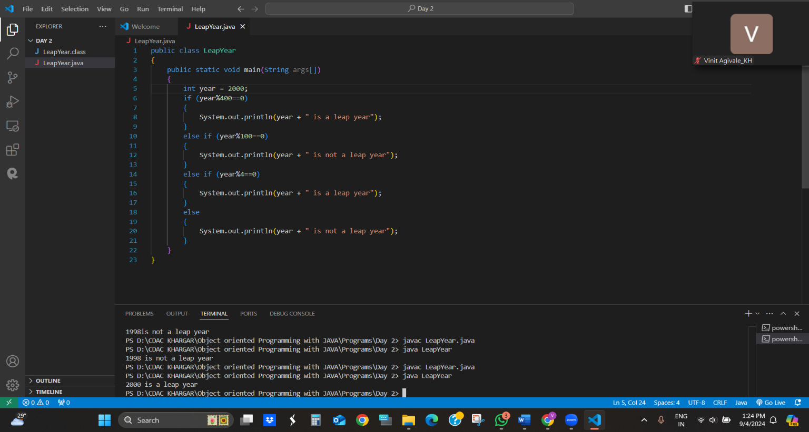

**Using switch case :**

import java.util.Scanner;

public class LeapYear_switch

{

    public static void main(String args[])

    {

        Scanner sc =new Scanner(System.in);

        System.out.println("Enter a year");

        int year = sc.nextInt();

        int caseValue=0;

        if(year%400==0)

        {

            caseValue=1;

        }

        else if(year%100==0)

        {

            caseValue=2;

        }

        else if(year%4==0)

        {

            caseValue=3;

        }

        switch(caseValue)

        {

            case 1:

            System.out.println(year +"is a leap year");

            break;

            case 2:

            System.out.println(year +"is not a leap year");

            break;

            case 3:

            System.out.println(year +"is a leap year");

            break;

             default:

                System.out.println(year + " is not a leap year.");

                break;

        }

    }

}

Output:

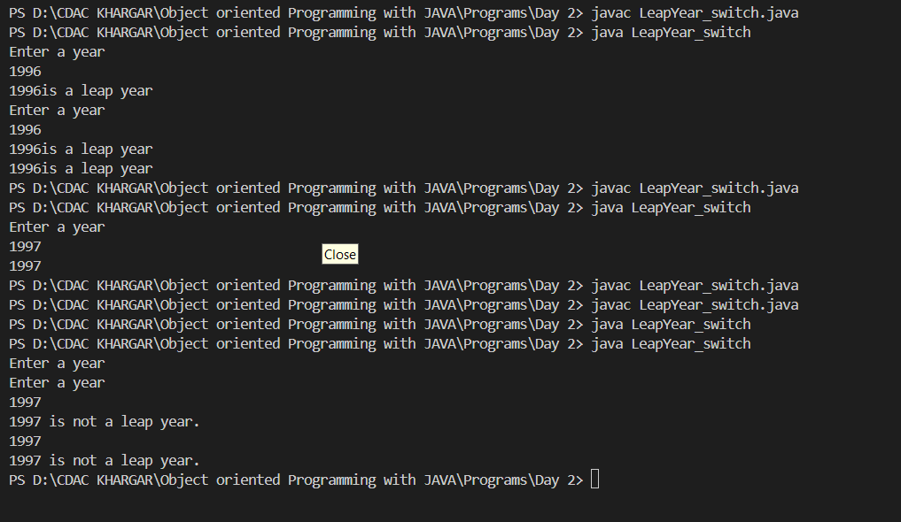

2)Implement a program that calculates the Body Mass Index (BMI) based on height and weight input using if-else to classify the BMI int categories (underweight, normal weight, overweight,etc).

Ans-

import java.util.Scanner;

public class Bmicalculator

{

    public static void main(String args[])

    {

        Scanner sc = new Scanner(System.in);

        //Get weight input from user

        System.out.println("Enter youur weight in kilograms:");

        double weight = sc.nextDouble();

        //Get height input from the user

        System.out.println("Enter your height in meters:");

        double height = sc.nextDouble();

        //calculate BMI

        double BMI = weight / (height * height);

        //Display BMI value

        System.out.printf("Your BMI is: %.2f%n", BMI);

        if(BMI<18.5) {

            System.out.println("You are underweight");

        }

        else if(BMI>= 18.5 && BMI<24.9)

        {

            System.out.println("You have a normal weight");

        }

        else if(BMI>=25 && BMI<34.9)

        {

            System.out.println("You are overweight");

        }

        sc.close();

    }

}

**Output:**

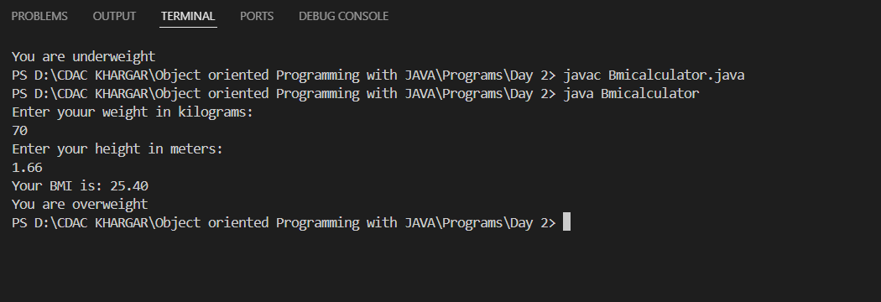

3)Write a program that checks if a person is eligible to vote based on their age.

import java.util.Scanner;

public class vote

{

    public static void main(String args[])

    {

        Scanner sc = new Scanner(System.in);

        System.out.println("Enter your age:");

        int age = sc.nextInt();

        if(age>=18)

        {

        System.out.println("You are eligible to vote");

        }

        else

        {

            System.out.println("You are not eligible to vote");

        }

        sc.close();

    }

}

Output:

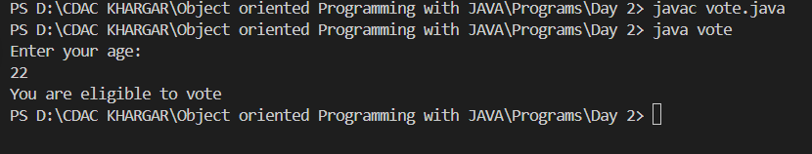

4)Write a program that takes a month (1-12) and prints the corresponding season (Winter, Spring, Summer, Autumn) using a switch case

Ans –

import java.util.Scanner;

public class SeasonDetector

{

    public static void main(String args[])

    {

        Scanner sc = new Scanner(System.in);

        System.out.println("Enter a month(1-12):");

        int month = sc.nextInt();

        String season;

        switch(month){

            case 12:  //December

                case 1: //January

                    case 2: //February

                    season = "Winter";

                    break;

                    case 3: //march

                        case 4: //April

                            case 5: //may

                             season = "Spring";

                             break;

                                case 6: //june

                                case 7: //july

                                case 8: //august

                                season ="Summer";

                                break;

                                case 9: //Sep

                                    case 10: //oct

                                        case 11: //nov

                                        season = "Autumn";

                                        break;

                                        default:

                                            season ="Invalid month. Please enter a number between 1 and 12.";

        }

        System.out.println("The season is: " + season);

        //close the scanner

        sc.close();

            }

}

Output-

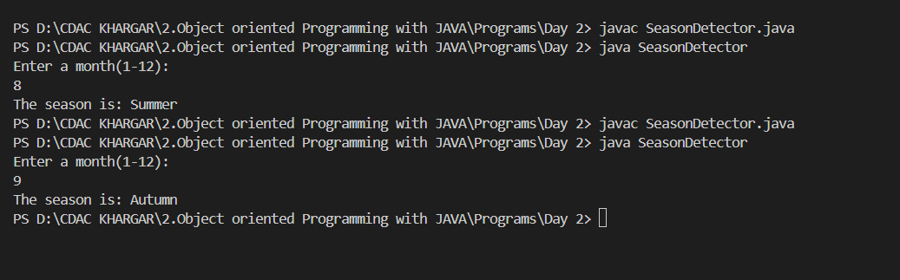

5)Write a program that allows the user to select a shape (Circle, Square, Rectangle, Triangle) and then calculates the area based on user-provided dimensions using a switch case.

import java.util.Scanner;

public class ShapeAreaCalculator {

    public static void main(String[] args) {

        Scanner scanner = new Scanner(System.in);

        System.out.println("Select a shape to calculate area:");

        System.out.println("1. Circle");

        System.out.println("2. Square");

        System.out.println("3. Rectangle");

        System.out.println("4. Triangle");

        int choice = scanner.nextInt();

        double area = 0;

        switch (choice) {

            case 1: // Circle

                System.out.println("Enter the radius of the circle:");

                double radius = scanner.nextDouble();

                area = Math.PI * radius * radius;

                break;

            case 2: // Square

                System.out.println("Enter the side length of the square:");

                double side = scanner.nextDouble();

                area = side * side;

                break;

            case 3: // Rectangle

                System.out.println("Enter the length and width of the rectangle:");

                double length = scanner.nextDouble();

                double width = scanner.nextDouble();

                area = length * width;

                break;

            case 4: // Triangle

                System.out.println("Enter the base and height of the triangle:");

                double base = scanner.nextDouble();

                double height = scanner.nextDouble();

                area = 0.5 * base * height;

                break;

            default:

                System.out.println("Invalid choice! Please select a valid shape.");

                return;  // Exit the program

        }

        System.out.println("The area of the selected shape is: " + area);

        scanner.close();

    }

}

